RIX2024 - Batch 1 – Could Computing Practical Assessment
12576 Nisanth Saravanan

Peer-to-Peer Learning Exchange

Abstract: Users exchange skills through scheduled learning sessions.
Entities: User, Skill, Session

W3H Analysis

Project Title: Peer-to-Peer Learning Exchange
What? |  | How?
1. What are the necessary modules?  A: Modules Needed:  1) Login and Registration.  2)User Dashboard.  2. What are the necessary functionalities of Login and Registration Modules?  A: Login and Registration Module:  1) Register User.  2) Login as User.  3. What are the necessary functionalities of User Dashboard?  A: User Dashboard:  1) Create, Update, Edit and Delete Sessions.  2) Create, Update, Edit and Delete Skills.  4. What are the tables needed?  A: Tables Required:  - Users  - Skills  - Sessions  5. What are the fields of Users table?  A: Fields of Users table:  - Id (Primary Key) - int  - Name – string  - Contact – int  6. What are the fields of the Skills table?  A: Fields of Skills Table:  - Id (Primary Key) - int  - SkillName – string  - Proficiency - int  7. What are the fields of the Session table?  A: Fields of Session Table:  - Id (Primary Key) - int  - Skill – string  - DateTime – DateTime  8. What are the validations in the application?  A: Overall validations list:  - Frontend simple JS Validations.  - Server Side validations.  - Form Validations. |  | Login and Registration Module:  1) Register User:  Method 1: Use Simple Form Page.  Method 2: Use a Modular Form Page.  Method 3: Use Google OAuth and other 3rd party services.  2) Login as User:  Method 1: Use Simple Form.  Method 2: Use a Modular Form.  Method 3: Use 3rd party services.  User Dashboard:  1) Create, Update, Edit and Delete Sessions:  Method 1: Use Simple Forms and Buttons to perform CRUD.  Method 2: Have separate pages for each operation  Method 3: Use Modals.  2) Create, Update, Edit and Delete Skills:  Method 1: Use Simple Forms and Buttons to perform CRUD.  Method 2: Have separate pages for each operation  Method 3: Use Modals.
Login and Registration Module:  1) Register User:  Method 1: Use Simple Form Page.  A: Since the overall scale of the application is small and data needed is rather minimal, it’s wise to stick with traditional forms.  2) Login as User:  Method 1: Use Simple Form.  A: Since the overall scale of the application is small and data needed is rather minimal, it’s wise to stick with traditional forms.  User Dashboard:  1) Create, Update, Edit and Delete Sessions:  Method 1: Use Simple Forms and Buttons to perform CRUD.  A: Since the overall scale of the application is small and data needed is rather minimal, it’s wise to stick with traditional forms.  2) Create, Update, Edit and Delete Skills:  Method 1: Use Simple Forms and Buttons to perform CRUD.  A: Since the overall scale of the application is small and data needed is rather minimal, it’s wise to stick with traditional forms. |  | Login and Registration Module:  1) Register User:  Method 2: Use a Modular Form Page.  A: Increases the complexity of the app, and also the fact that the number of needed inputs in rather minimal.  Method 3: Use Google OAuth and other 3rd party services.  A: Valid method but due to the scale of the application, this method is seemingly overkill.  2) Login as User:  Method 2: Use a Modular Form.  A: Increases the complexity of the app, and also the fact that the number of needed inputs in rather minimal.  Method 3: Use 3rd party services.  A: Valid method but due to the scale of the application, this method is seemingly overkill.  User Dashboard:  1) Create, Update, Edit and Delete Sessions:  Method 2: Have separate pages for each operation.  A: Since the user needs all information in one place and also that the number of operations they can do is limited, it is best to have a single page control centre type.  Method 3: Use Modals.  A: The modals pose a constant pop up like environment while performing CRUD operations.  2) Create, Update, Edit and Delete Skills:  Method 2: Have separate pages for each operation.  A: Since the user needs all information in one place and also that the number of operations they can do is limited, it is best to have a single page control centre type.  Method 3: Use Modals.  A: The modals pose a constant pop up like environment while performing CRUD operations.
Why? |  | Why Not?

Output Screenshots

Prepare the application…

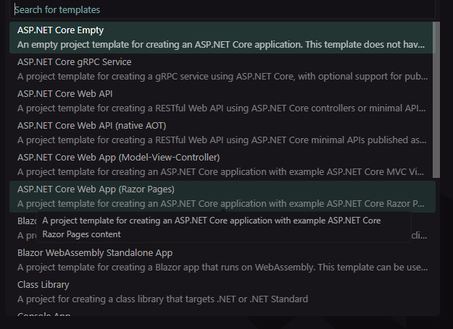
Log into Azure Portal

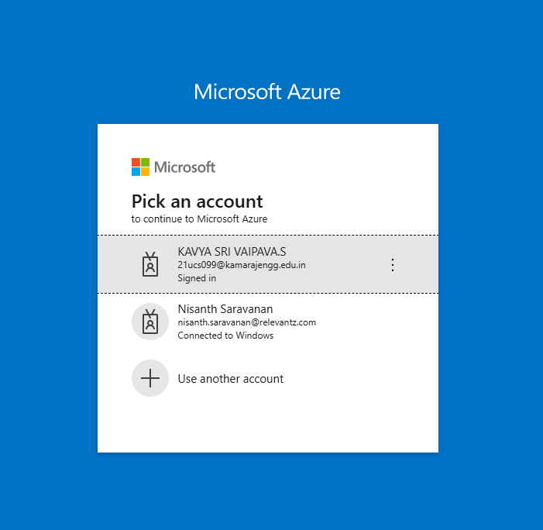
Create a new resource group

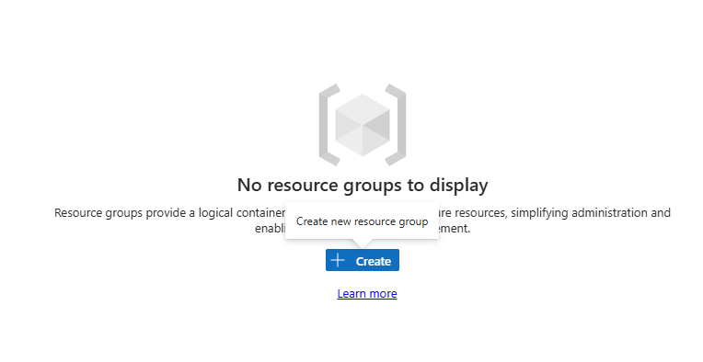

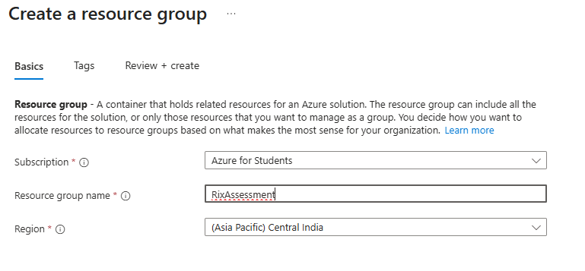
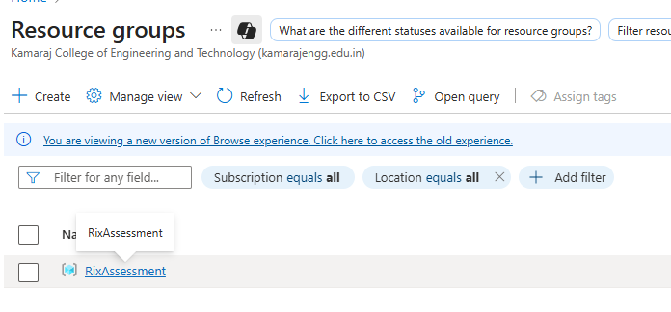

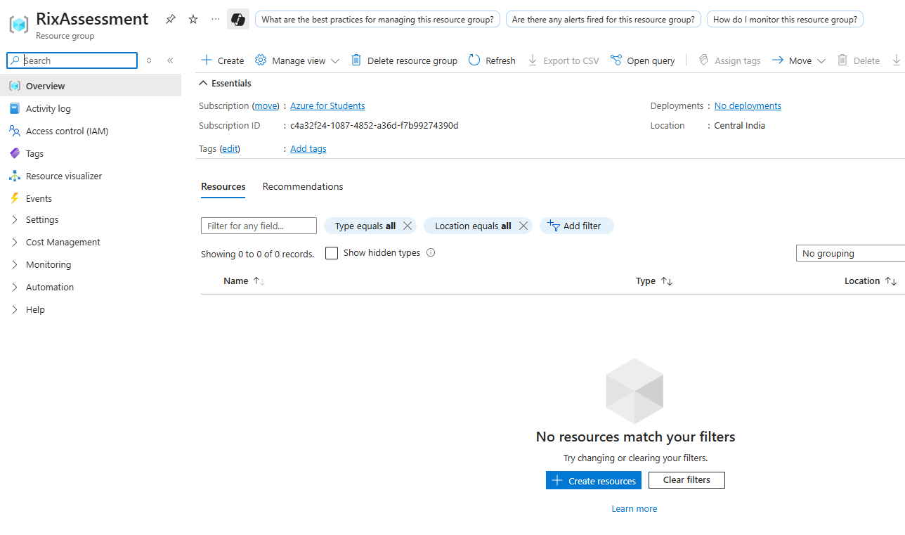
Create a SQL server and db in the resource group

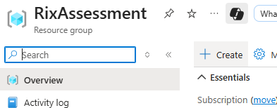

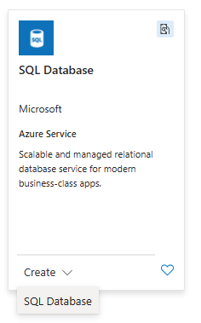
Create a SQL Server

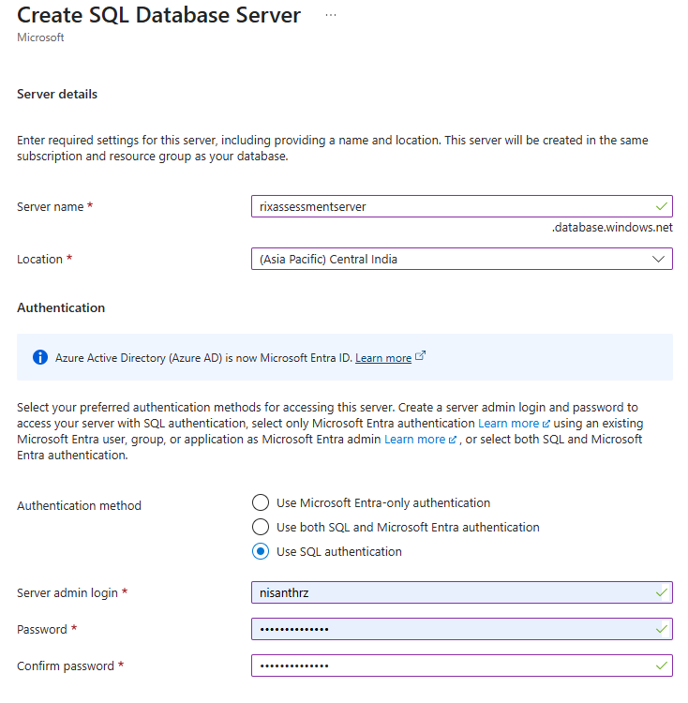
Create a SQL Database

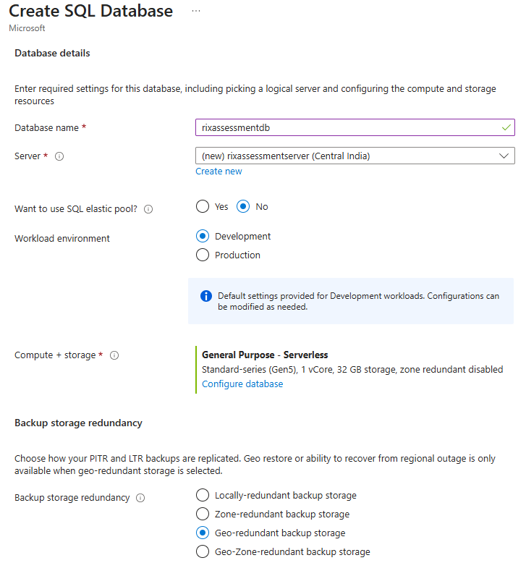
Configuring the SQL Database

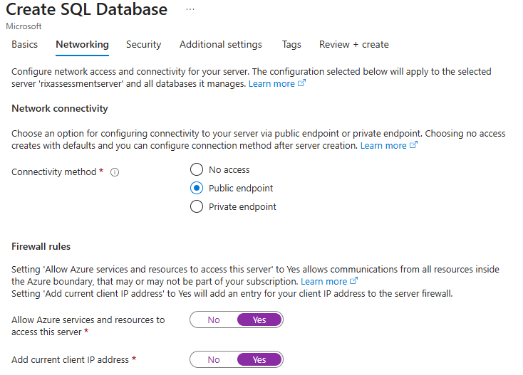
Review and Create

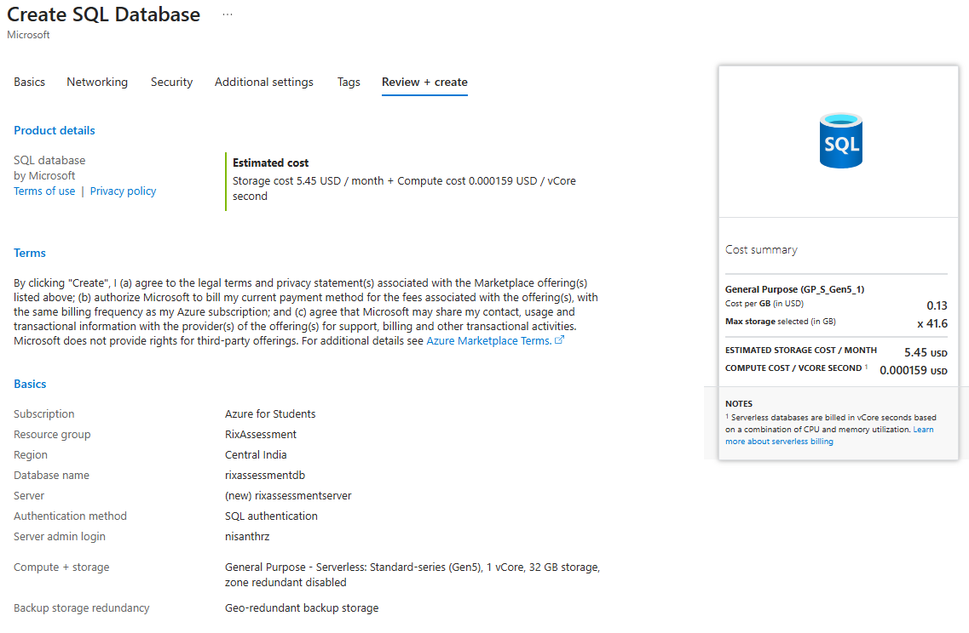

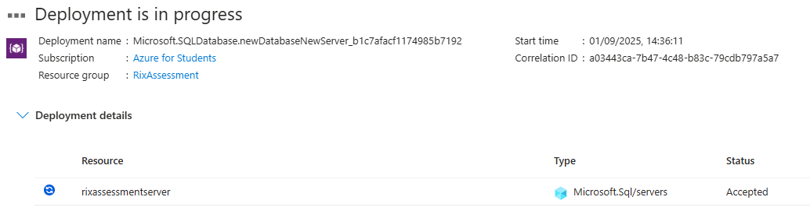

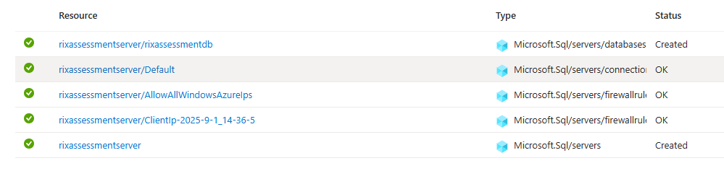
Go to the resource

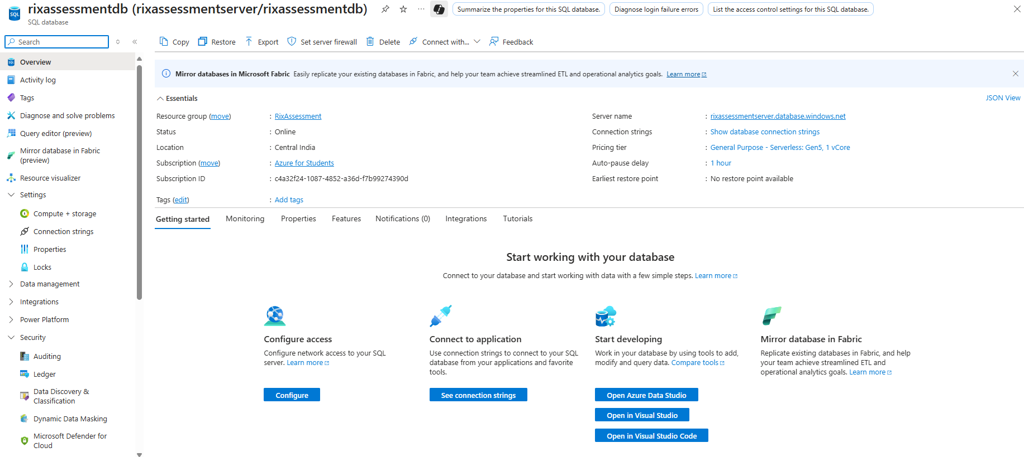
Obtain Connection Strings

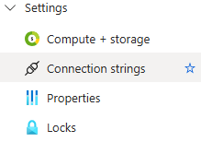

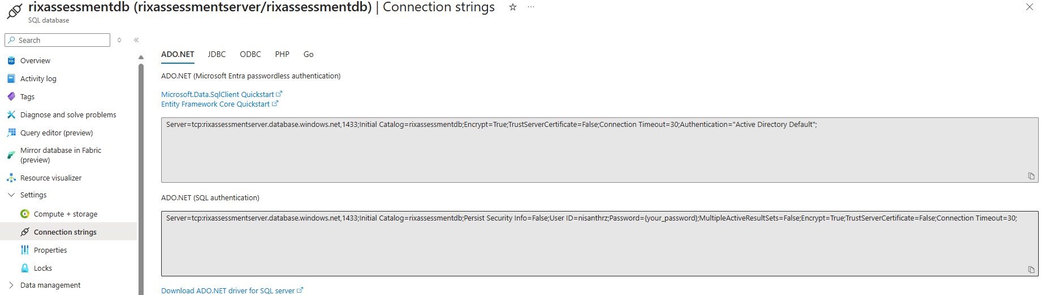

Copy the 2nd link and utilize it in the project for migrations…

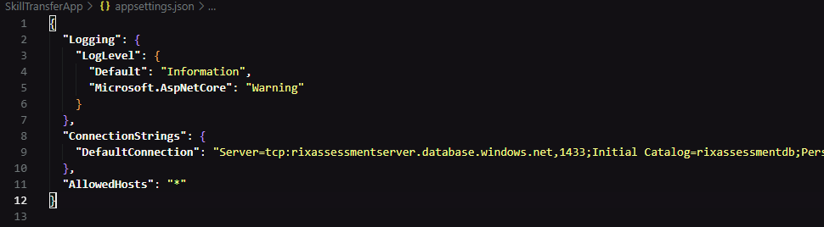
Migrate and update Database

Migrations Successful

Database Update Failed

To resolve this error, Go to the resource on Azure Portal

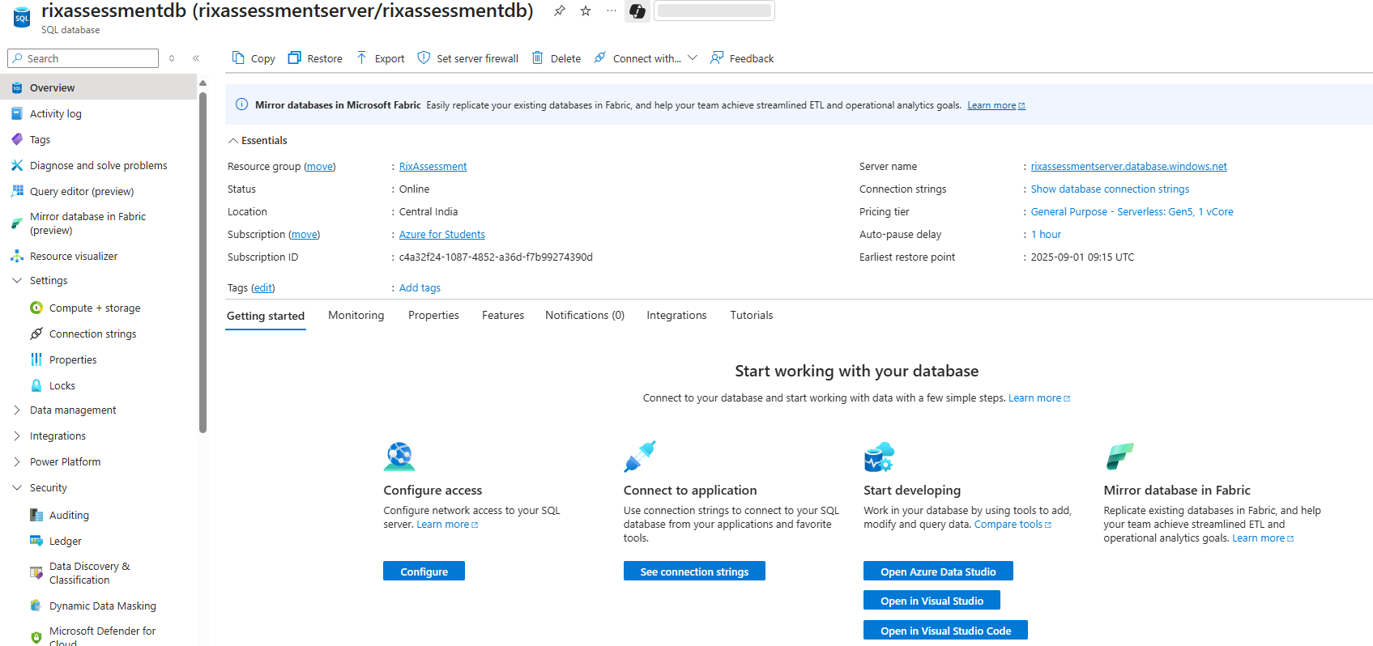

Navigate to the SQL Server

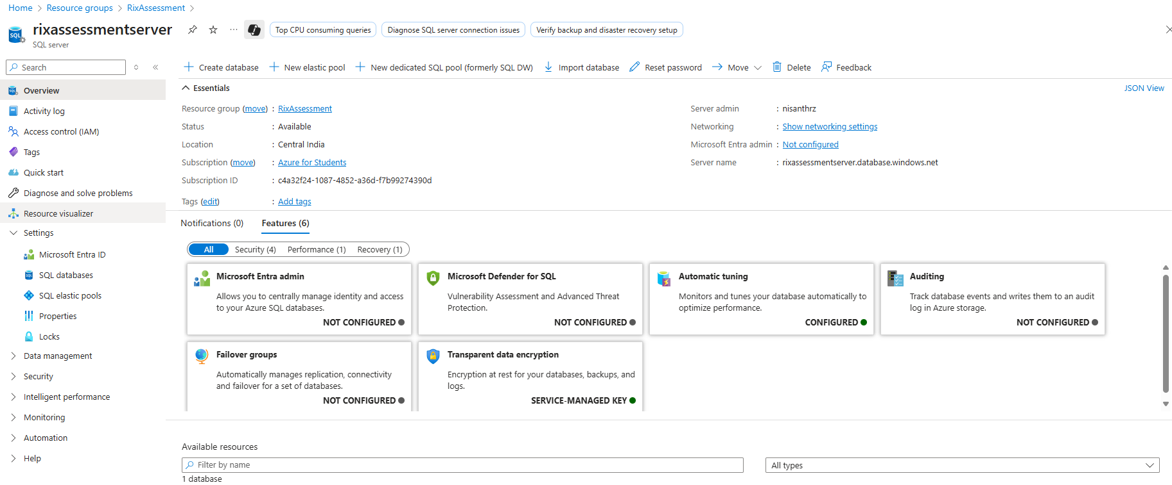
Move to Networking Settings user Security

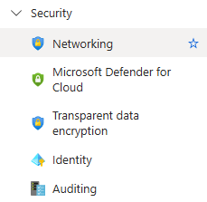

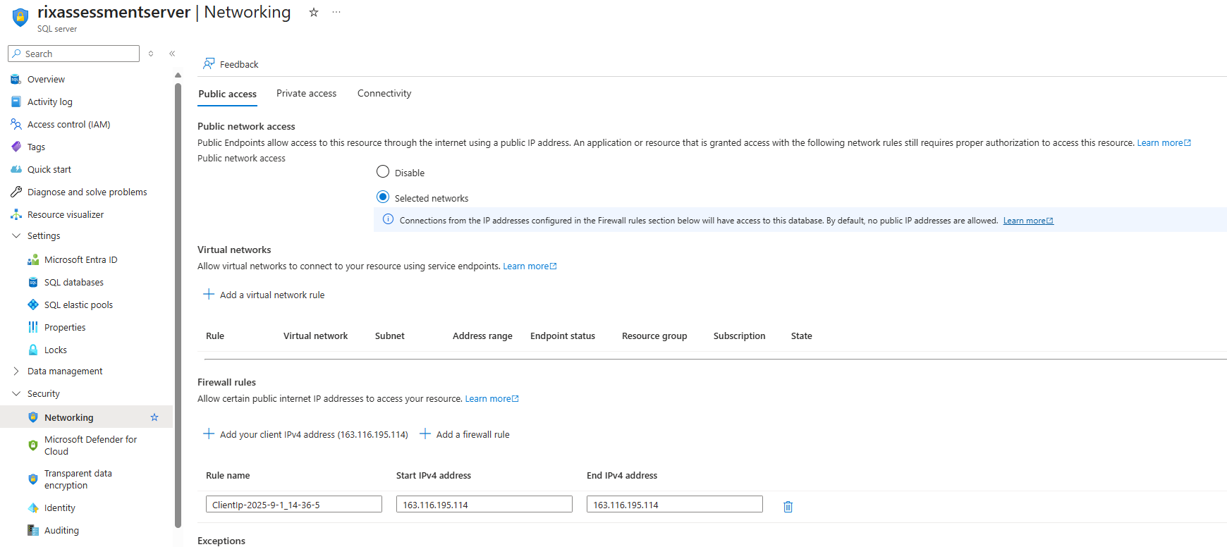
Add a new firewall rule under Public Access

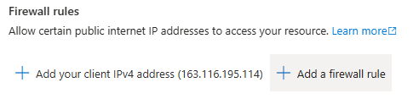

Provide IP range to cover all possible IPv4 Addresses, just this once

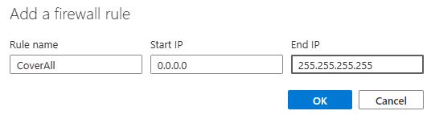

Save

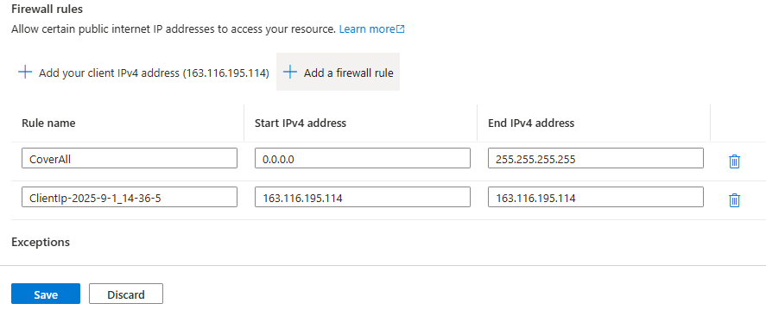
Retry DB Update

Success

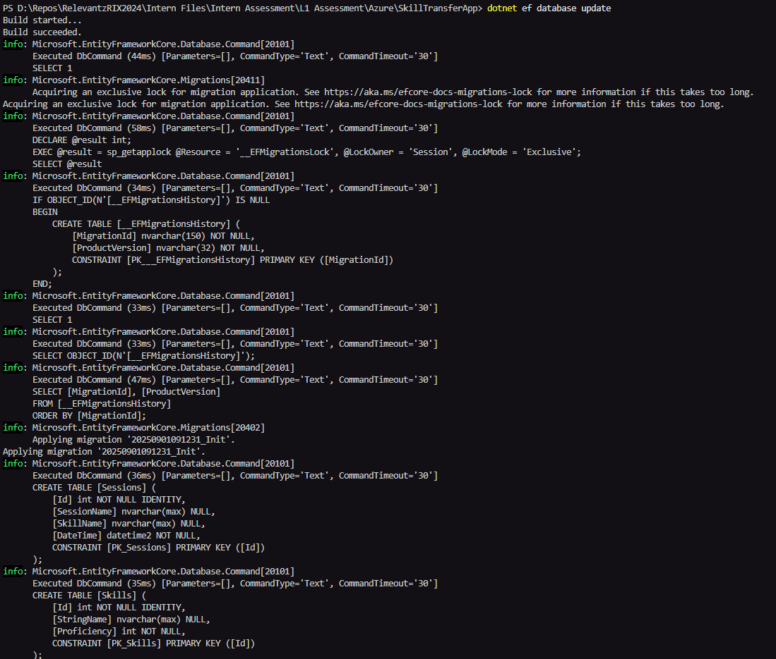
Creating a BLOB Storage

Navigate to the resource group

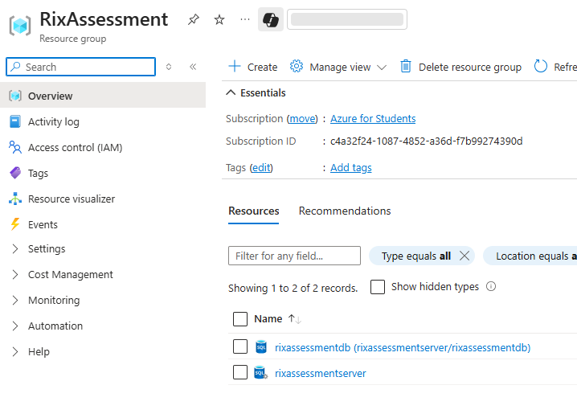

Create a new storage account

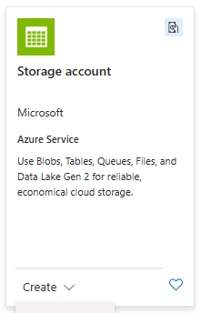

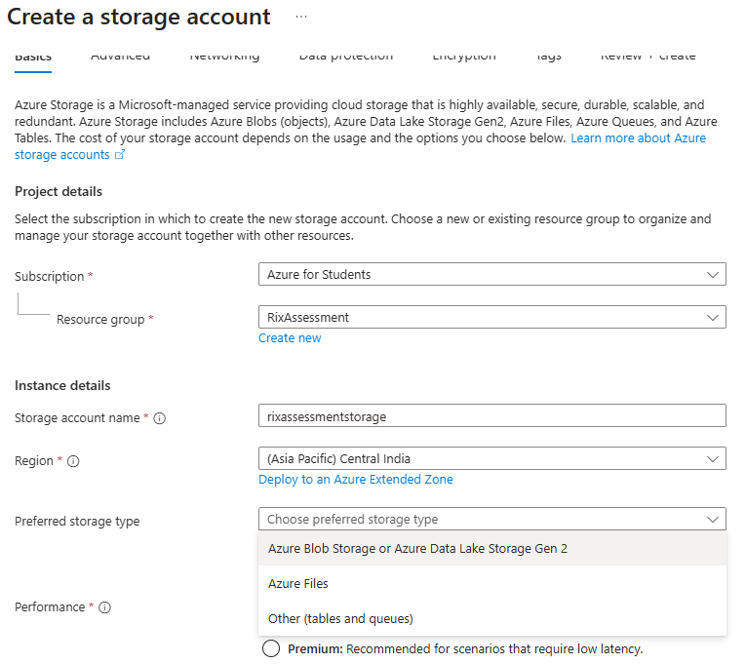

Review and create

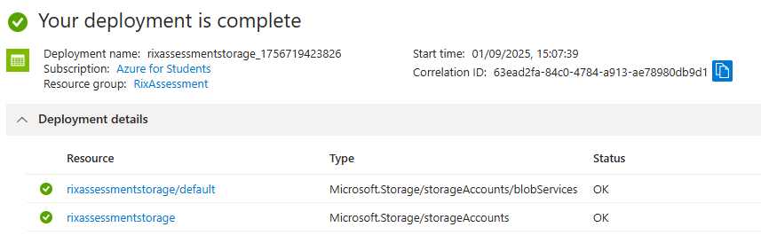

Go to resource

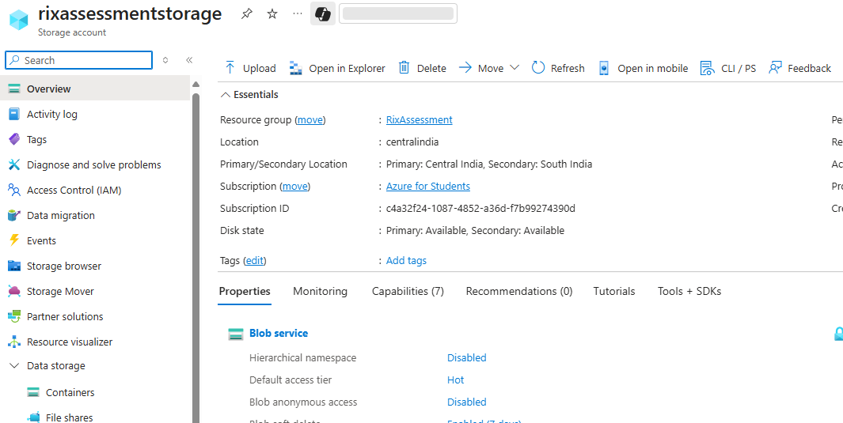
Enable Anonymous Access

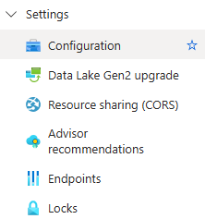

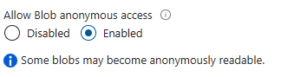

Save Changes
Navigate to containers and create a new container

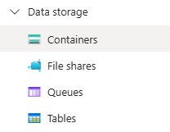

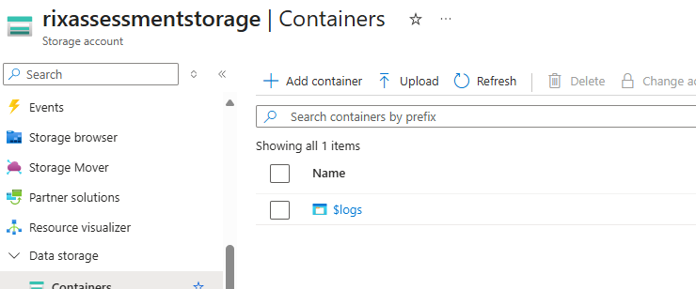

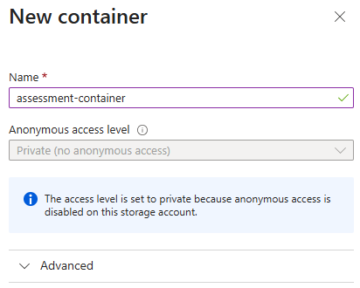
Change access level

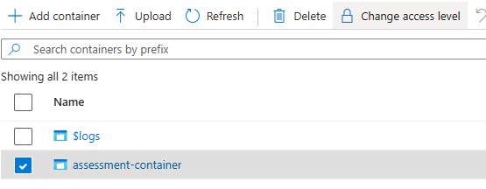

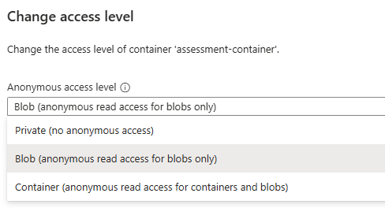

Save Changes
Open the Container

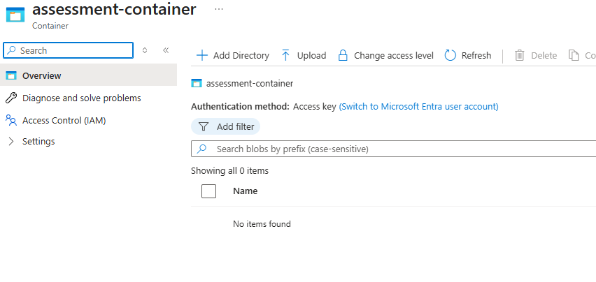

ZIP your project and upload it into the BLOG Storage container



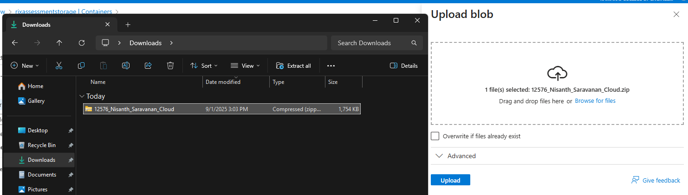
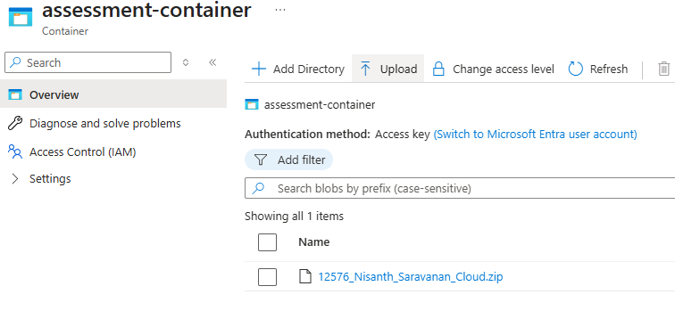

Open the uploaded file to get the download link for later…

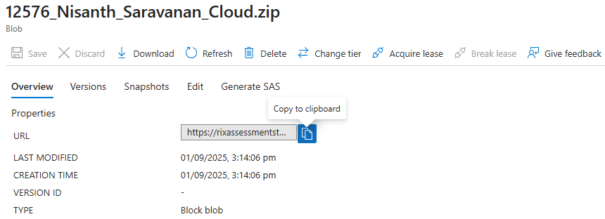
Create a VM

Navigate to resource group

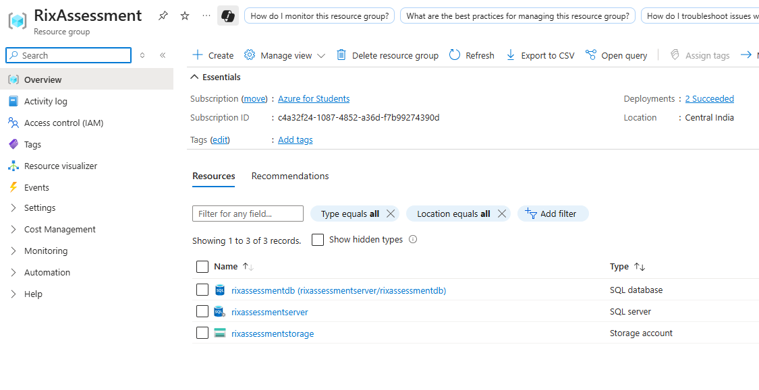

Create a new VM

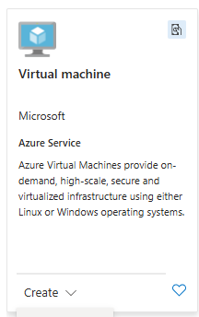
Configuring the creation

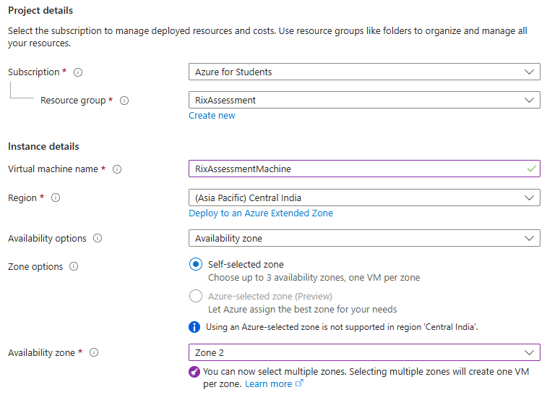

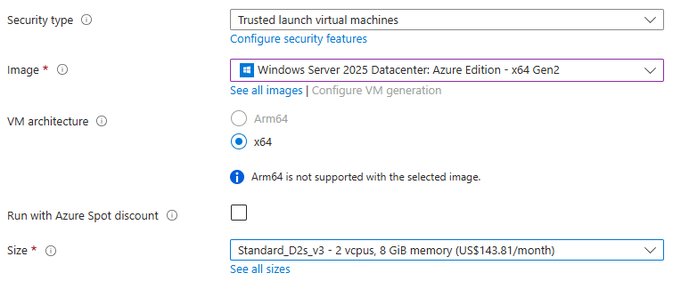

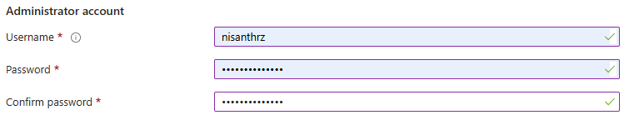
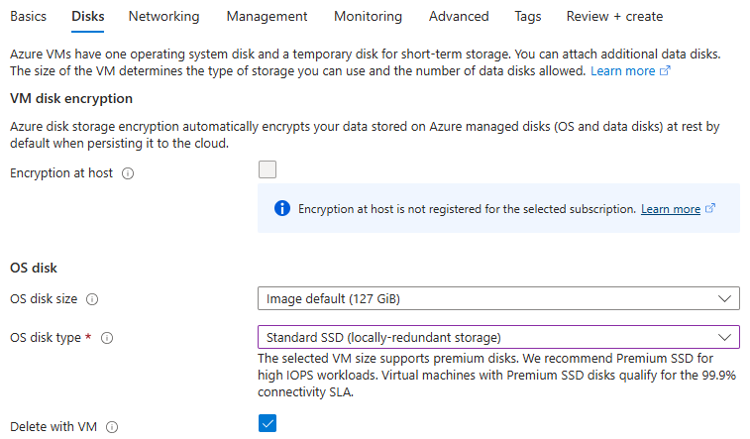

Review and create

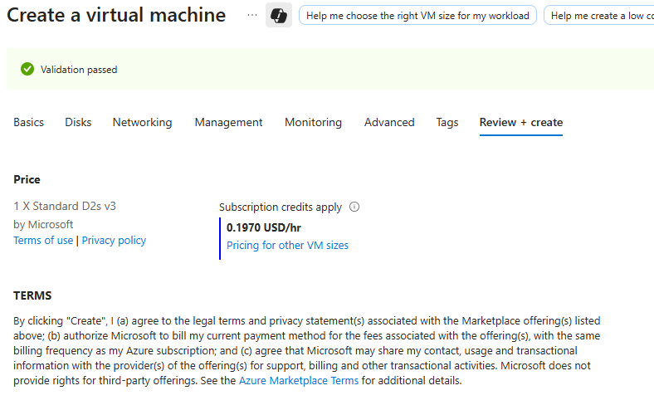
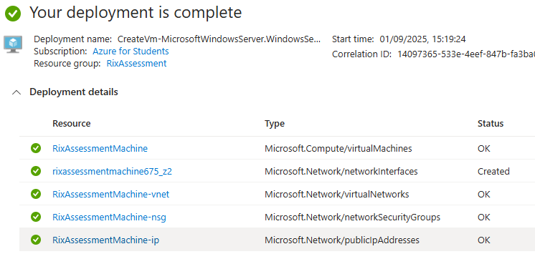

Go to resource

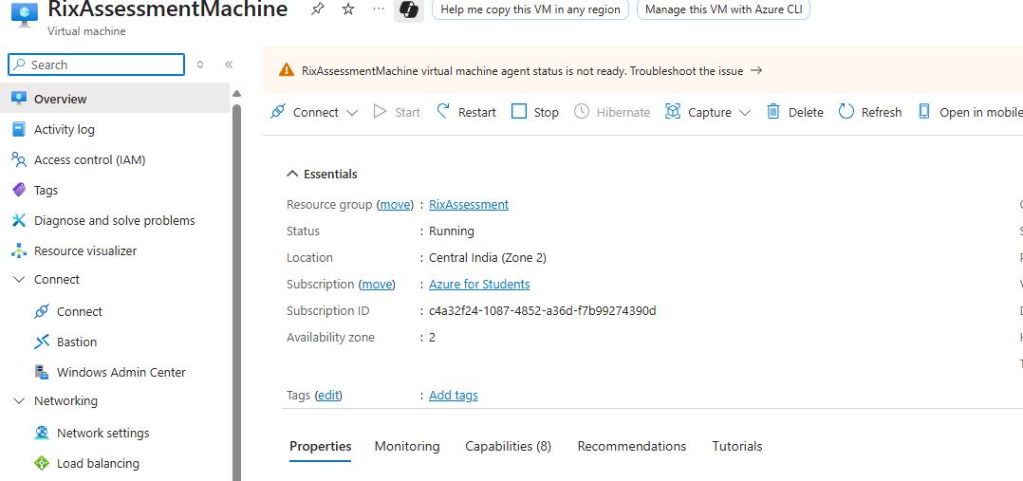
Connection to our VM

Navigate to Connect

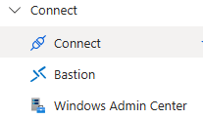

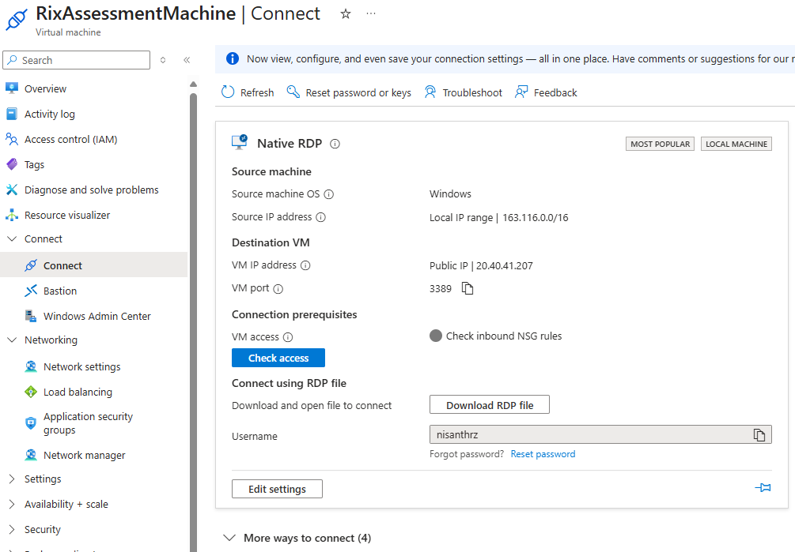
Check access to native RDP port and download the RDP File

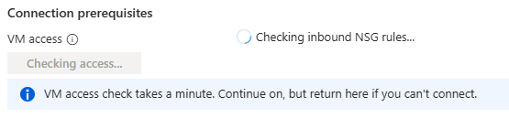

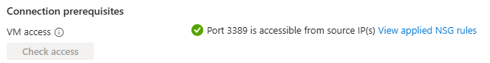

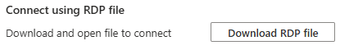

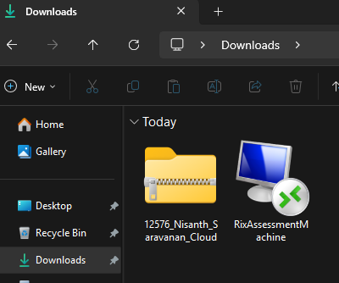
Open the RDP File

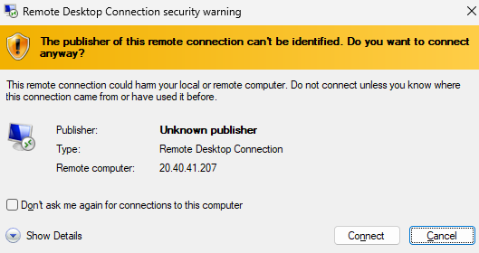

Enter the credentials

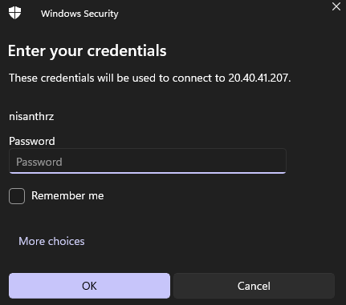
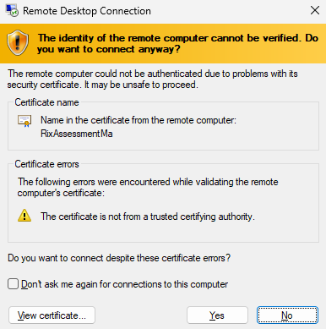

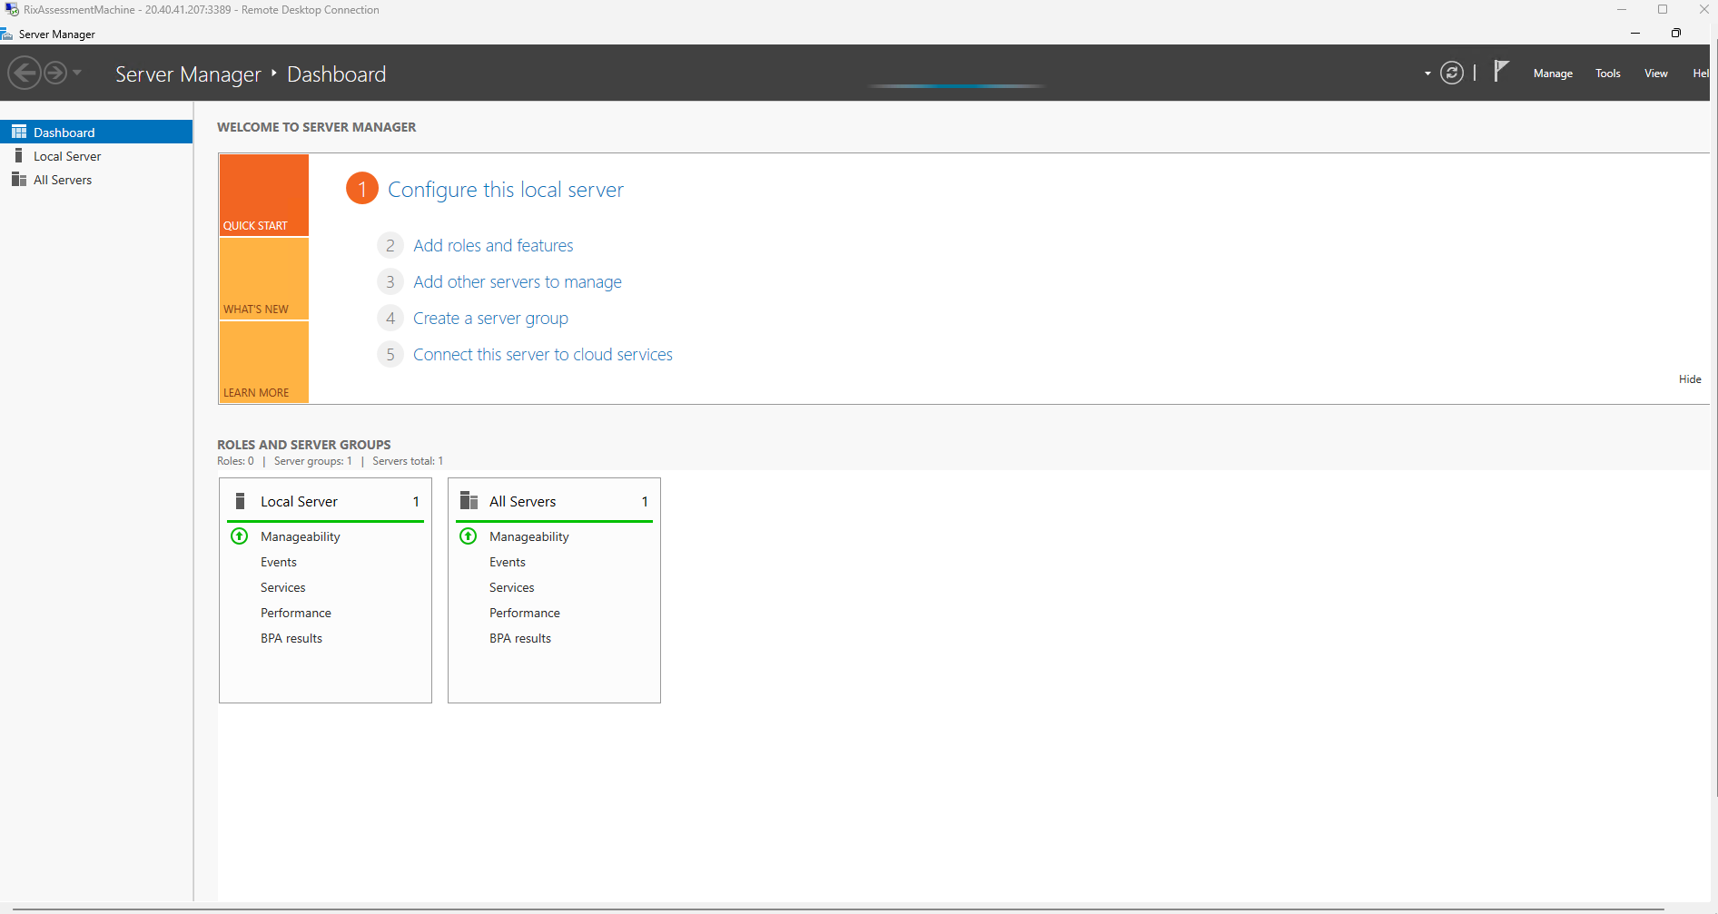
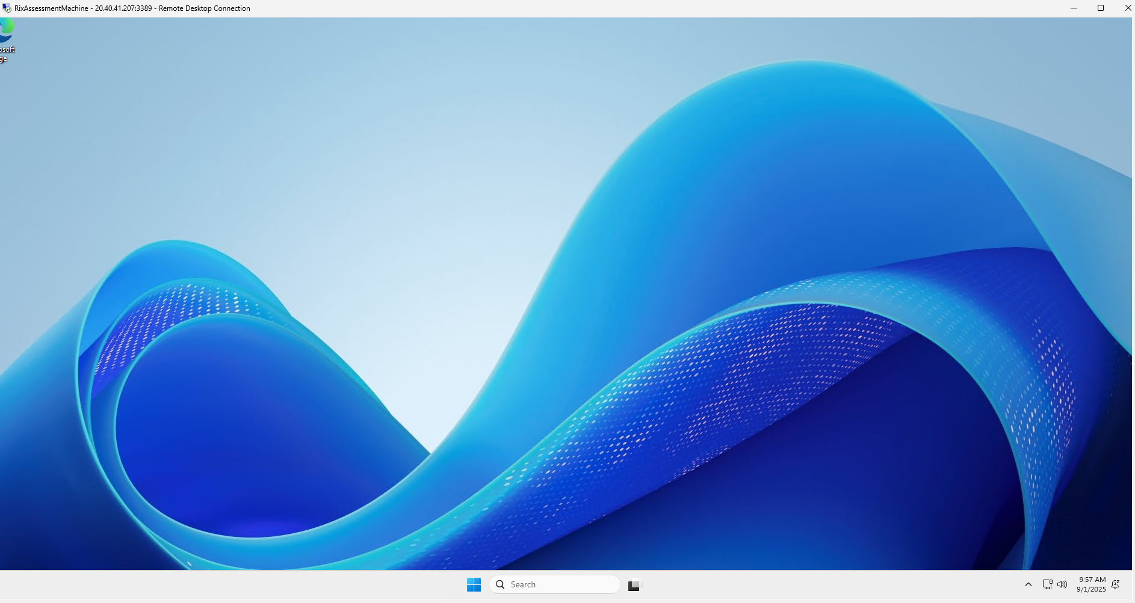

Donload Visual Studio Code and .NET SDK

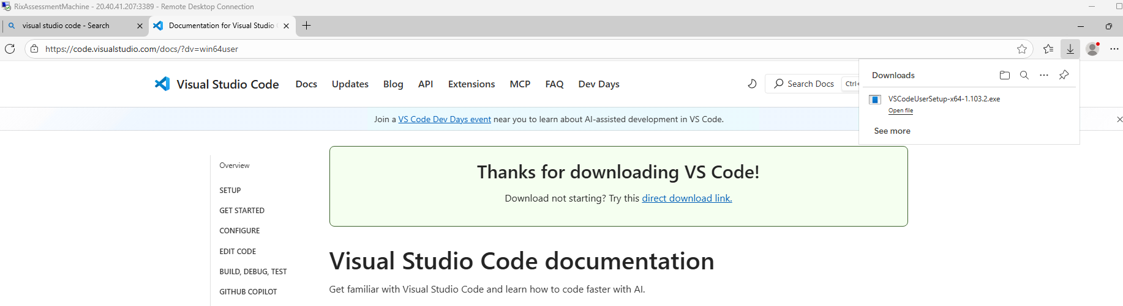

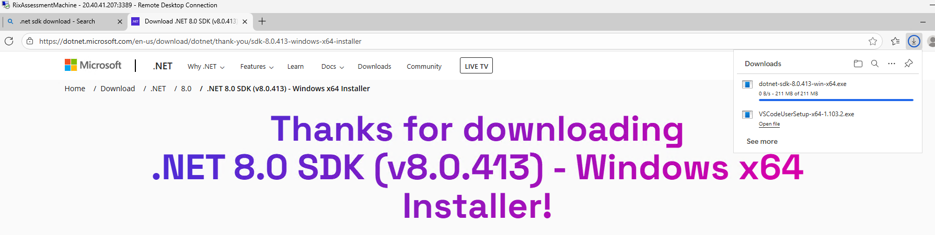
Install them both

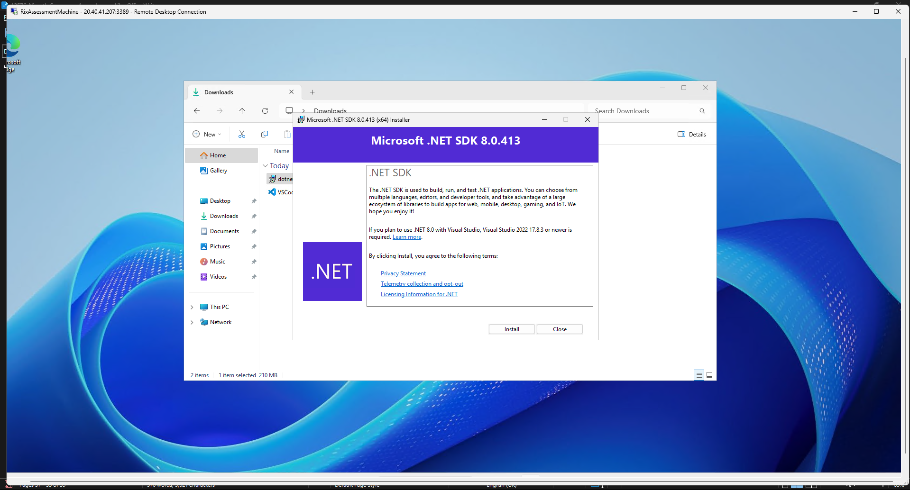

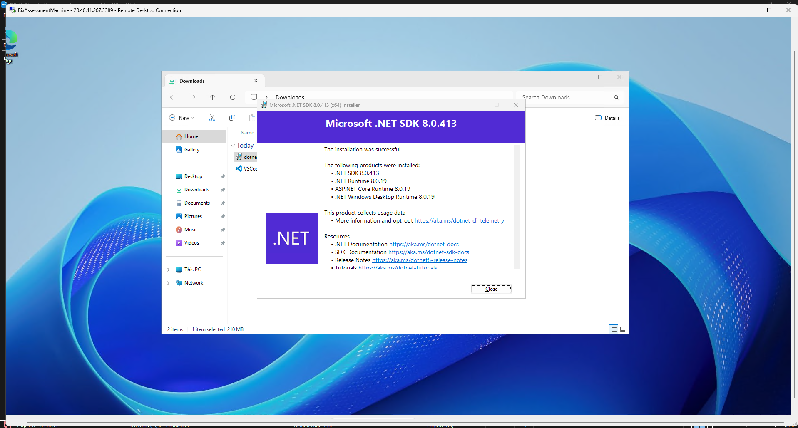
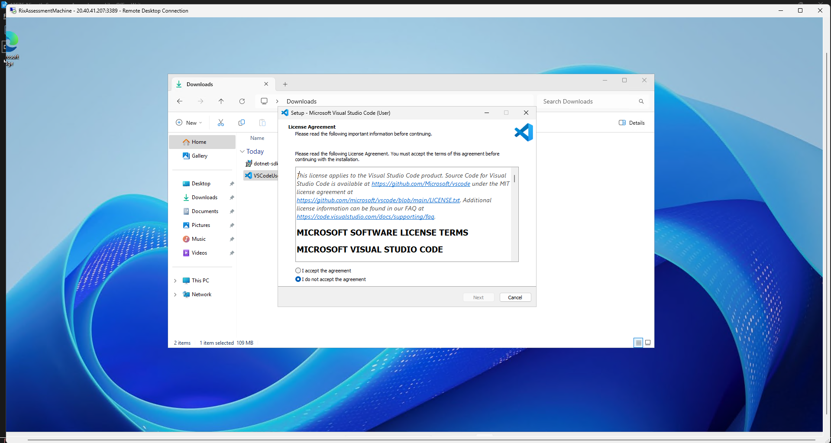

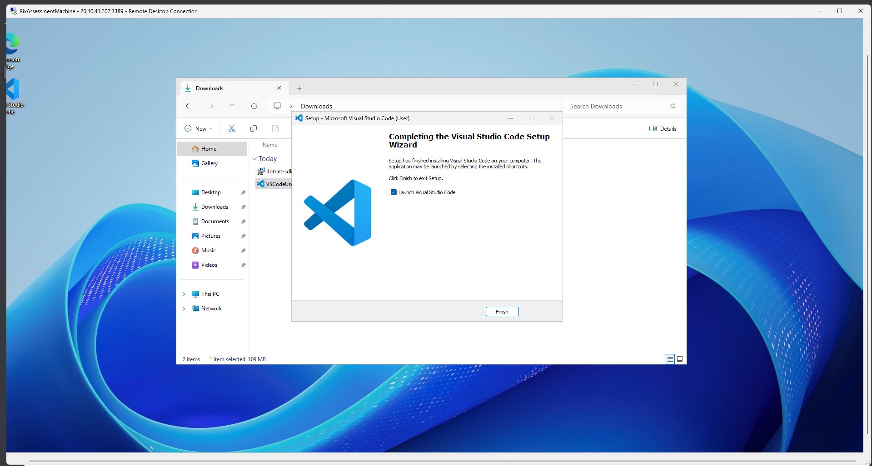
Importing the project into the VM

Return to the BLOB Storage and navigate to out file that is already inside a container

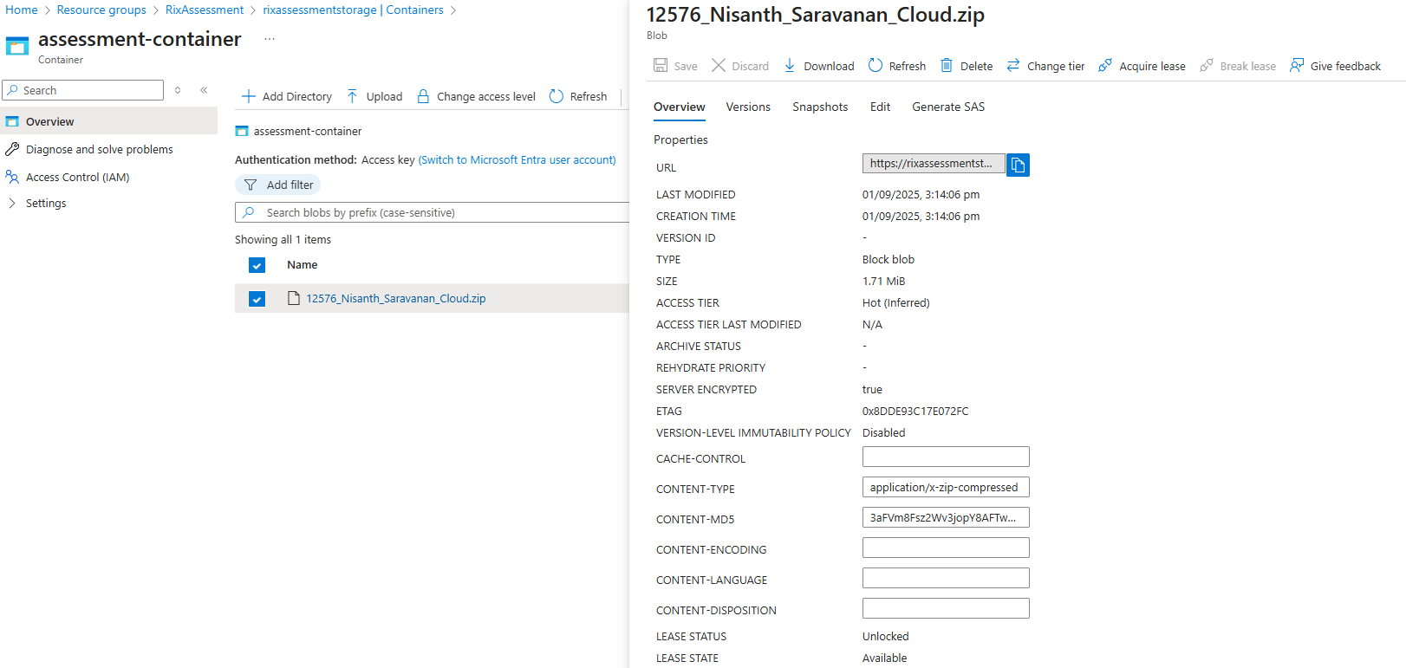

Copy the URL

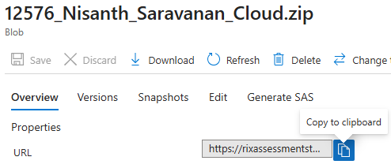
Paste the URL in the address bar of the browser within our VM

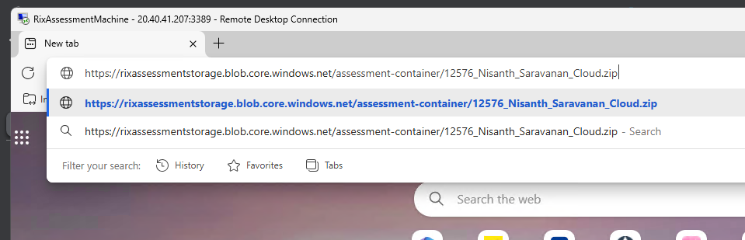

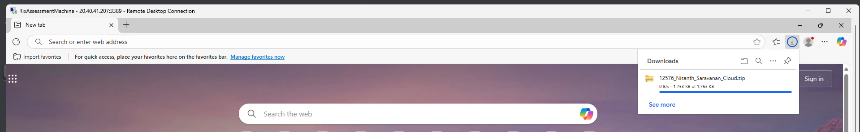

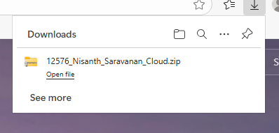
Extract the project and run it

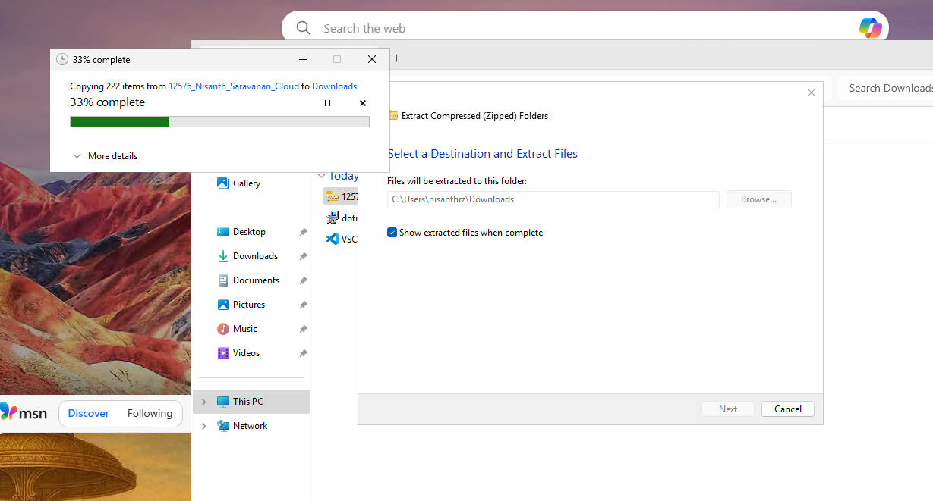

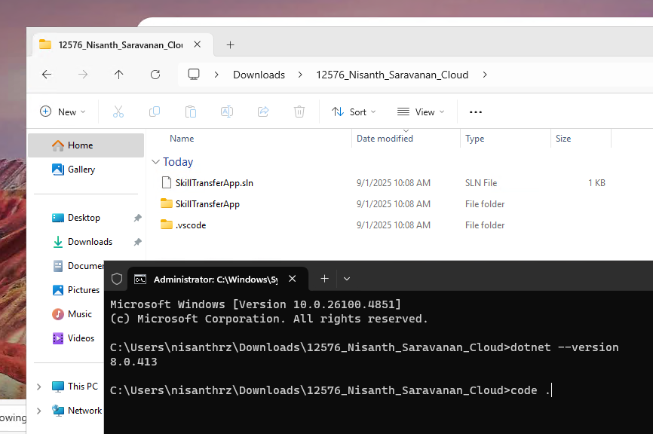
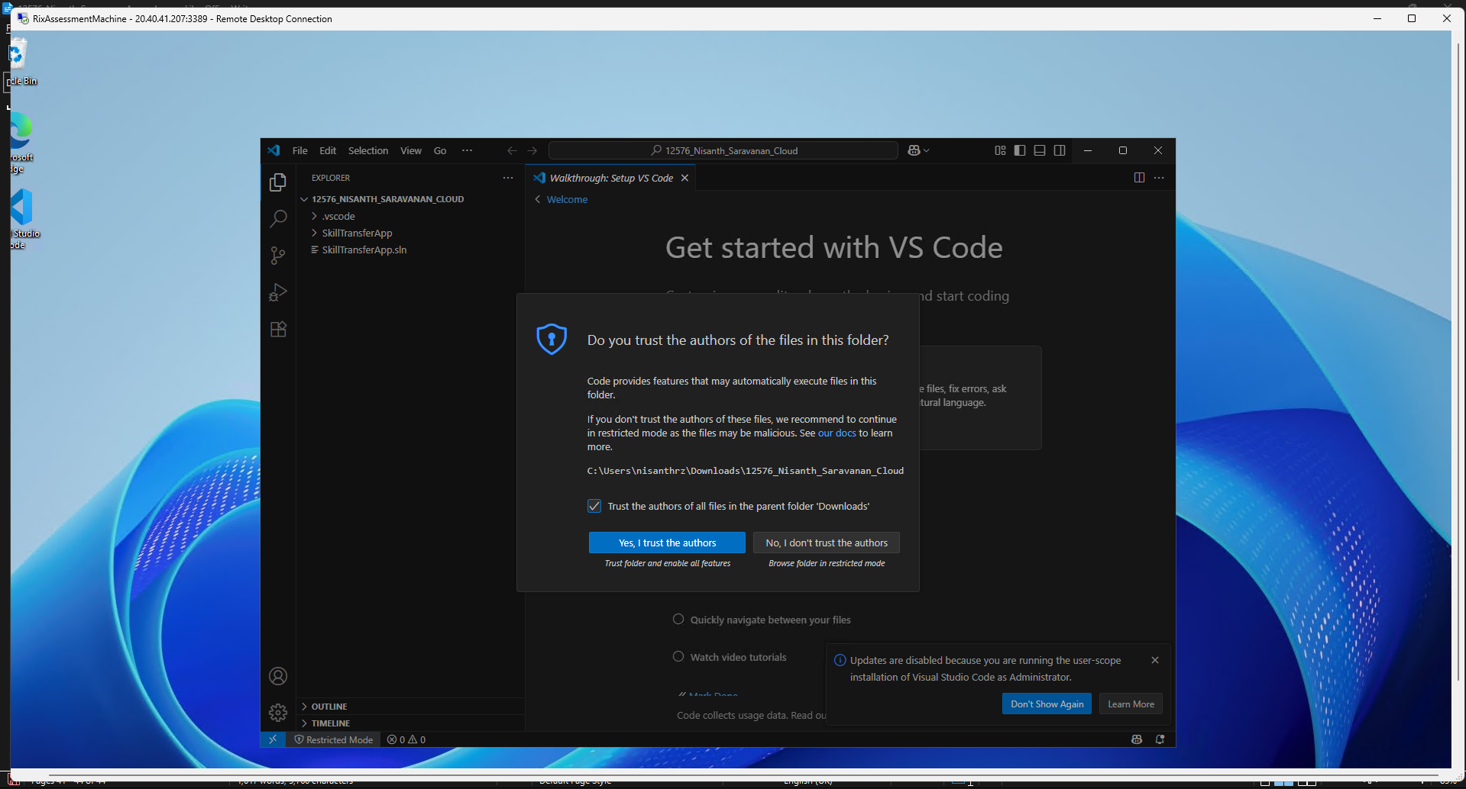

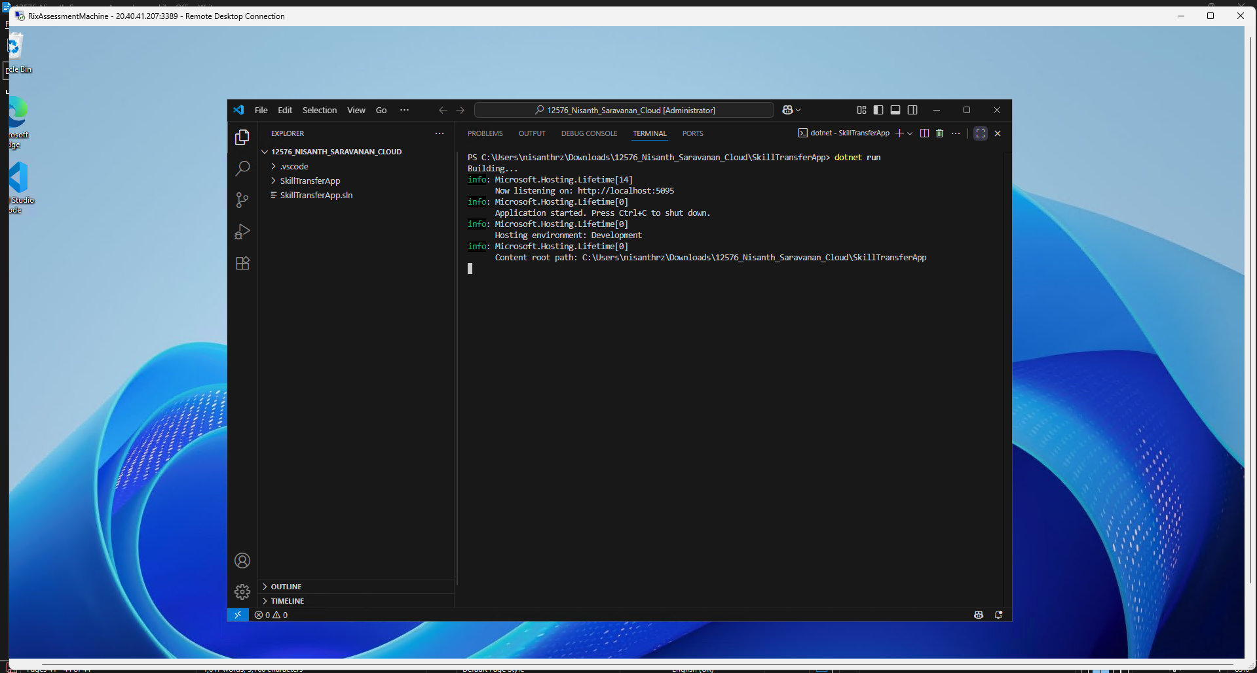

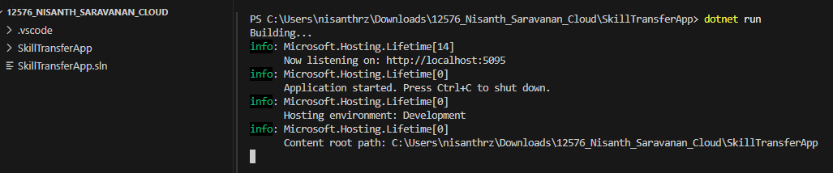
Output inside the VM

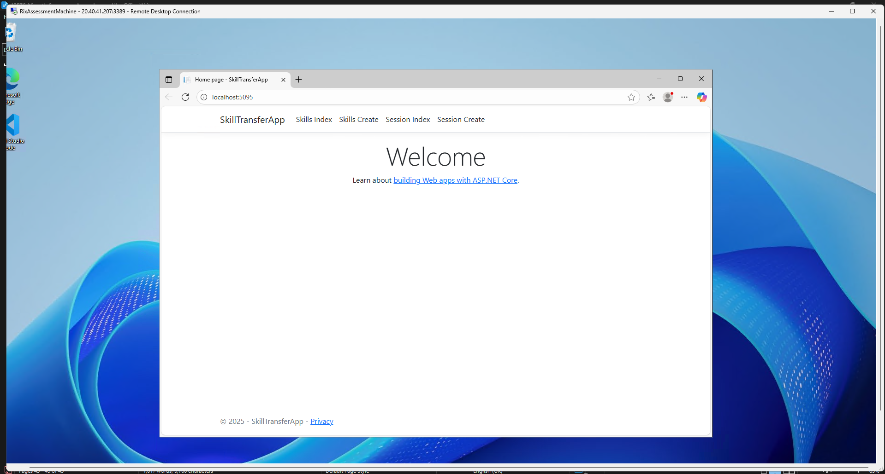

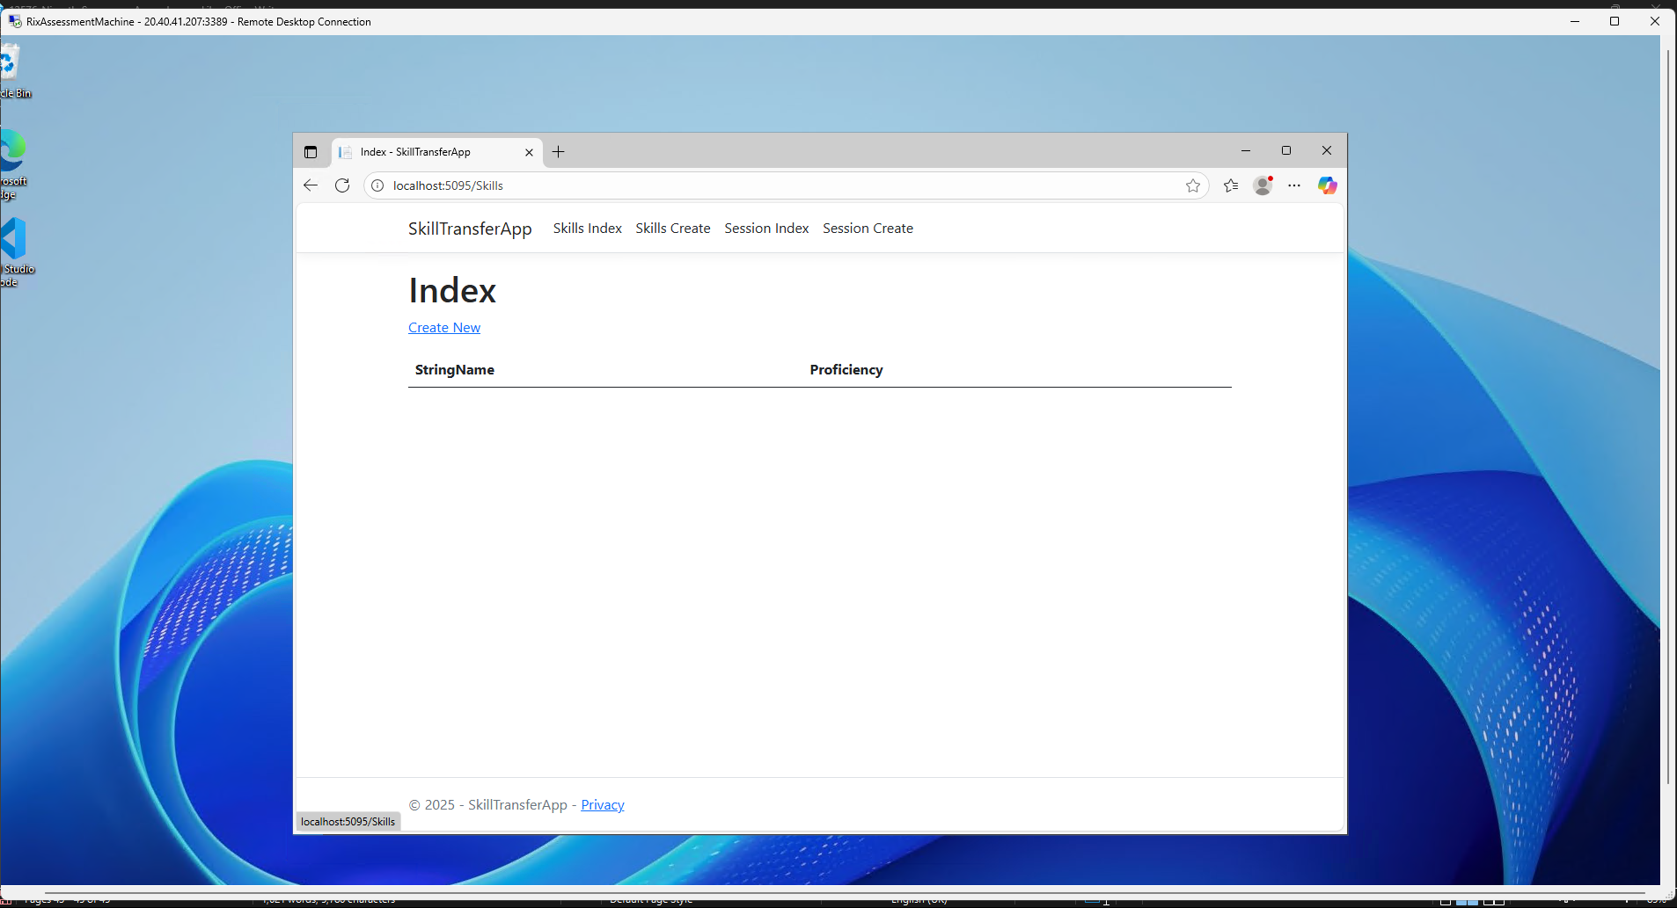
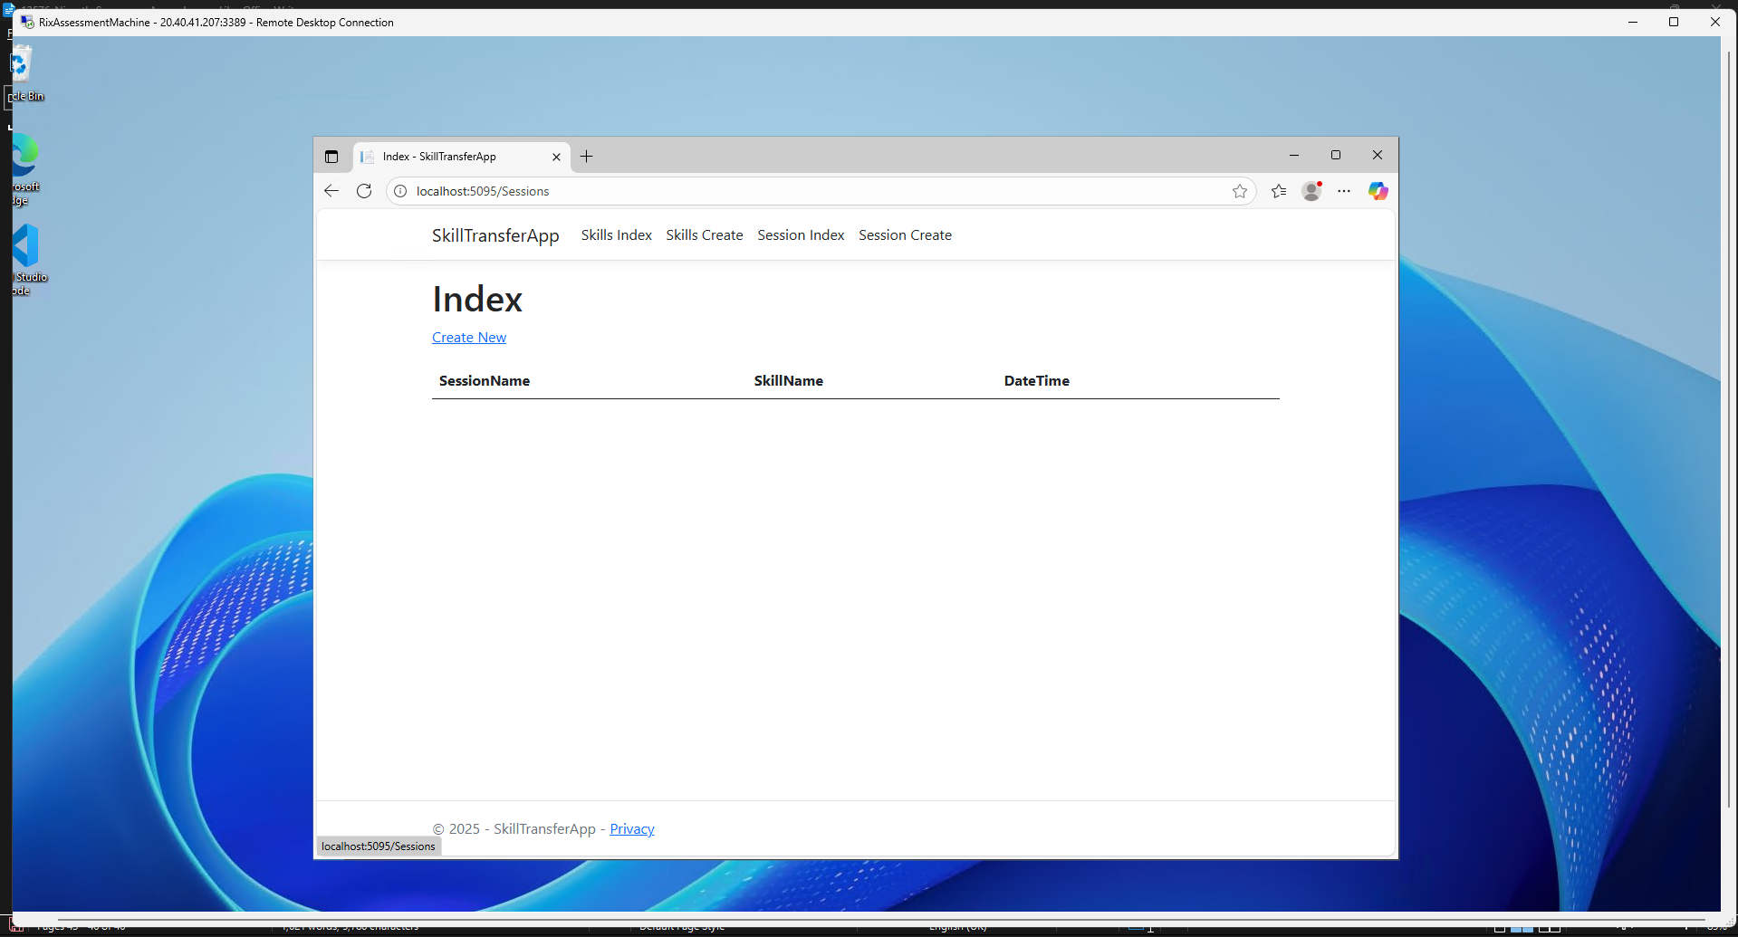

CRUD Operations and SQL Reflections

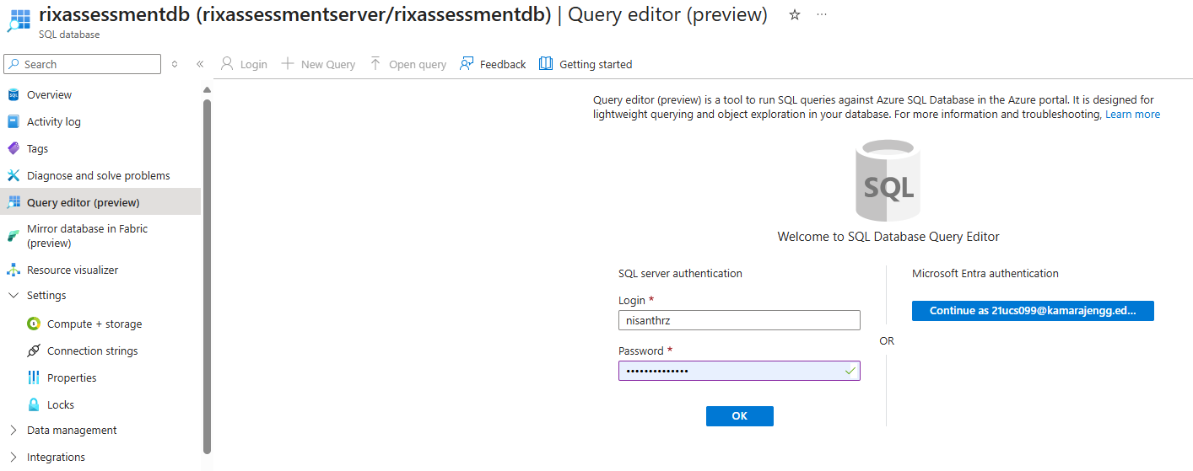

Skills

Initial

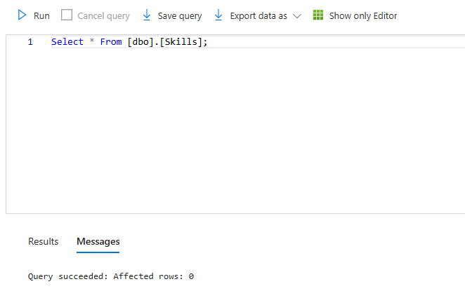
Create

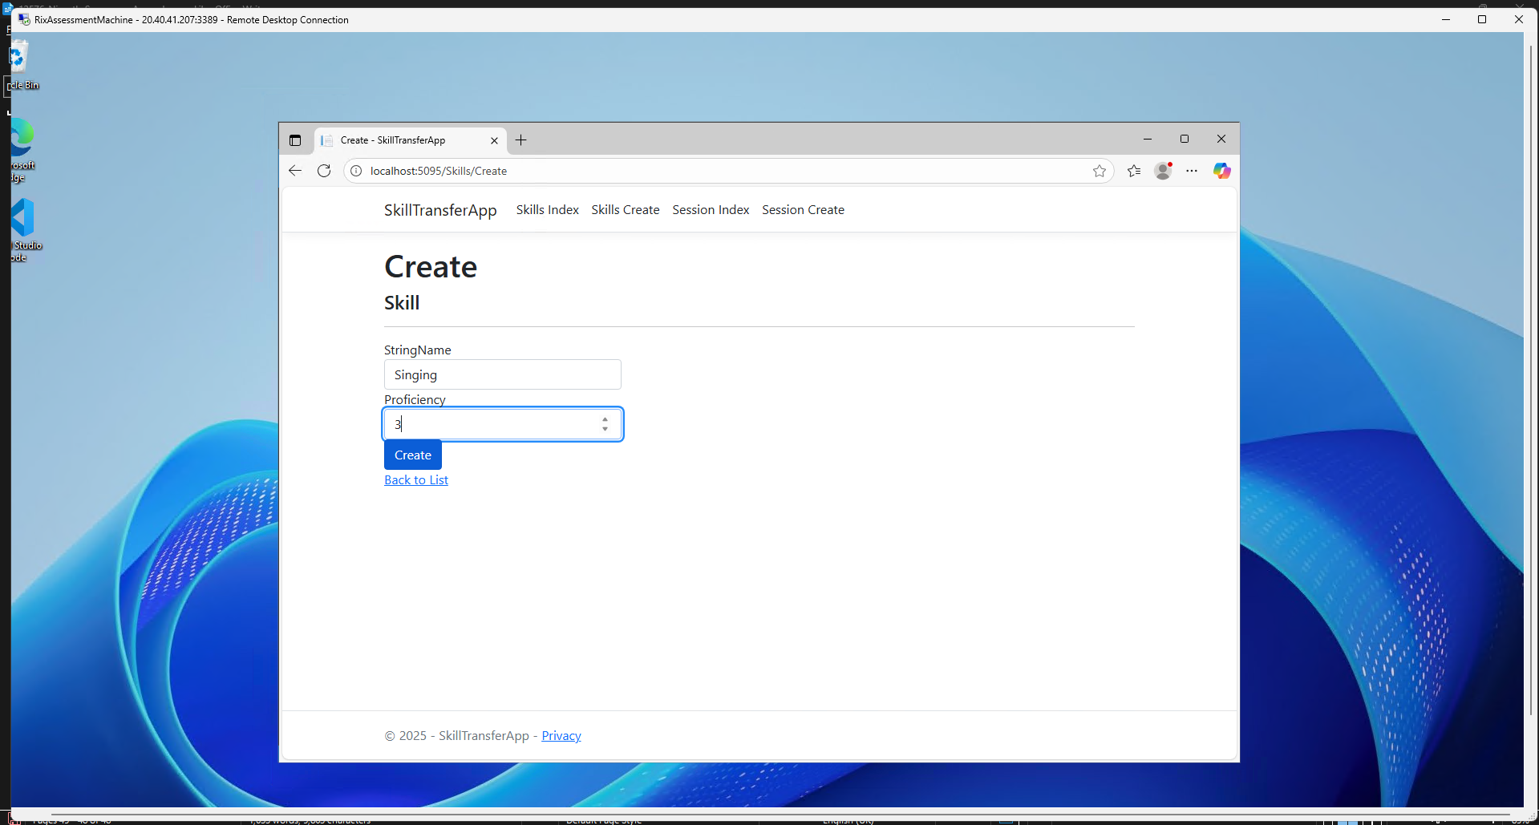

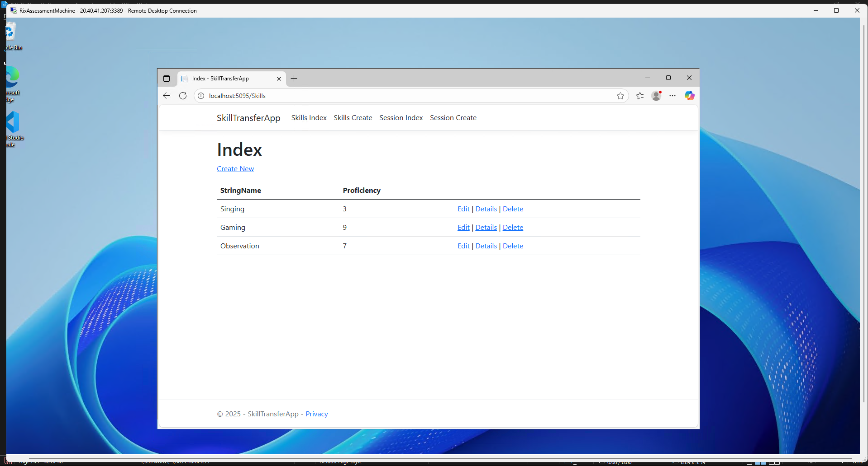
Reflection

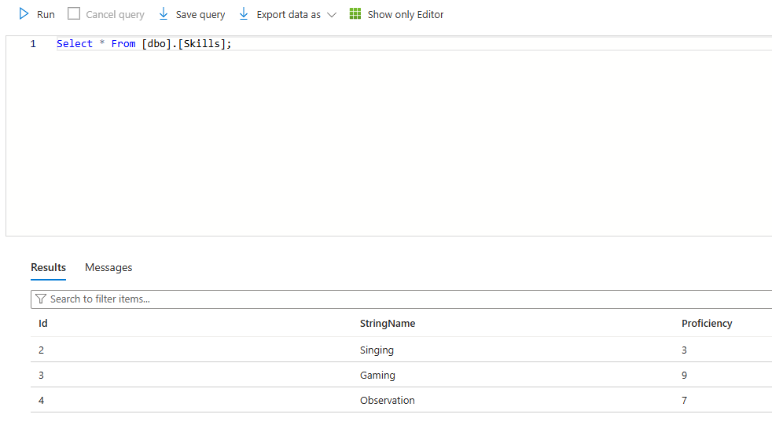

Edit

Initial

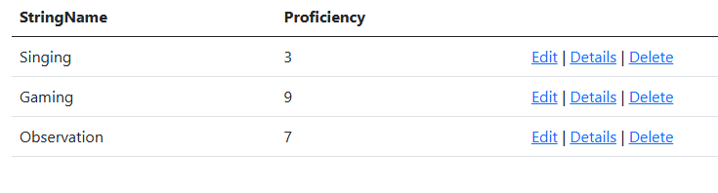

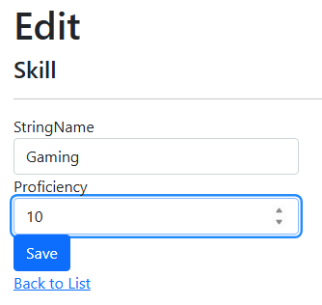
Reflection

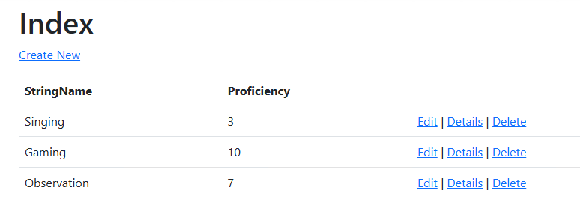

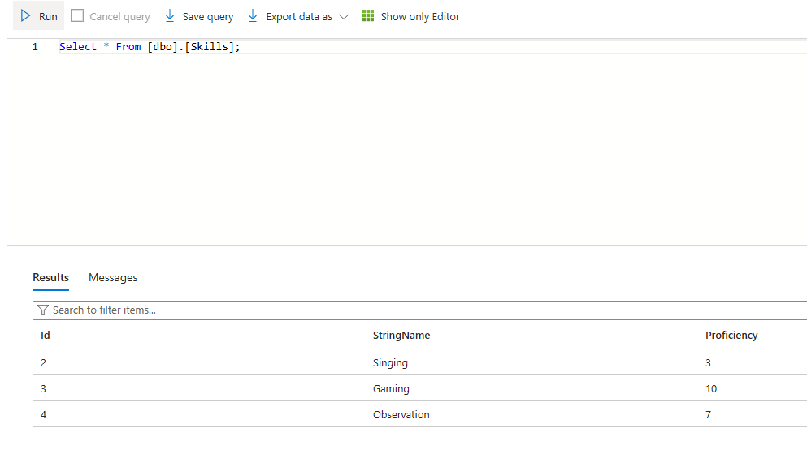
Delete

Initial



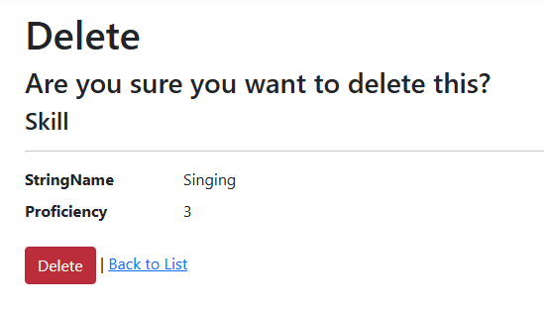
Reflection

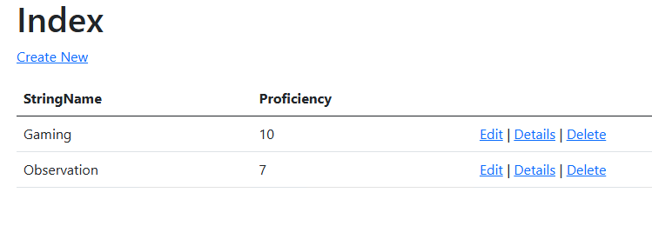

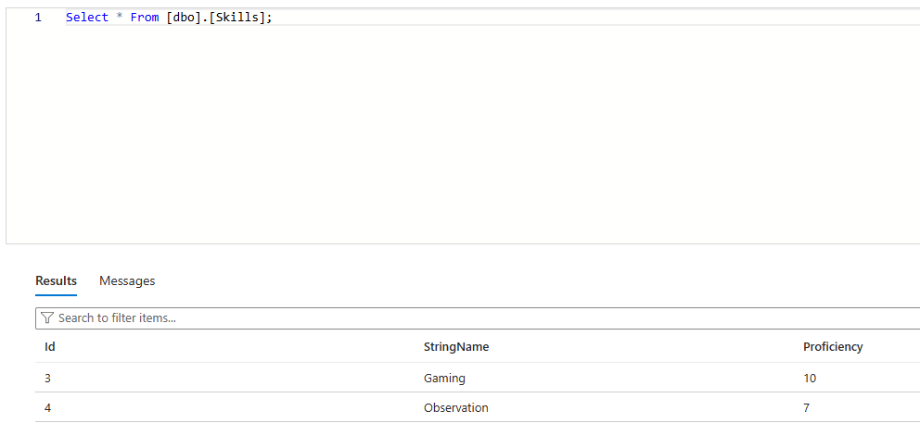
Sessions

Initial

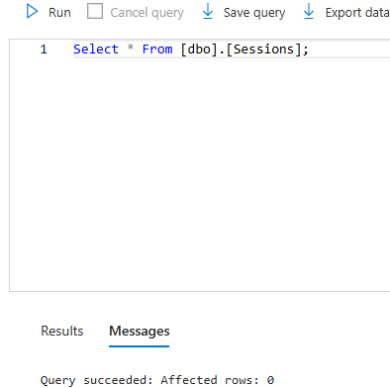

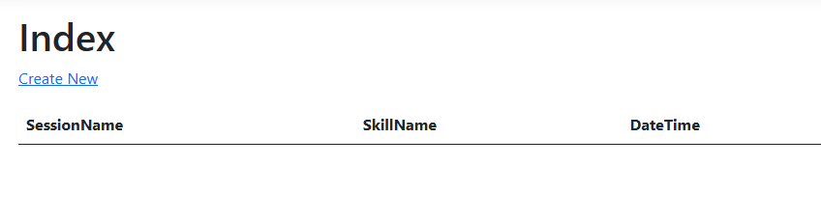
Create

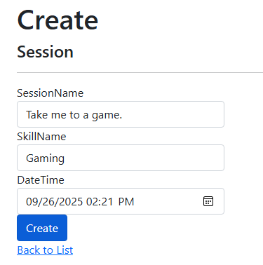

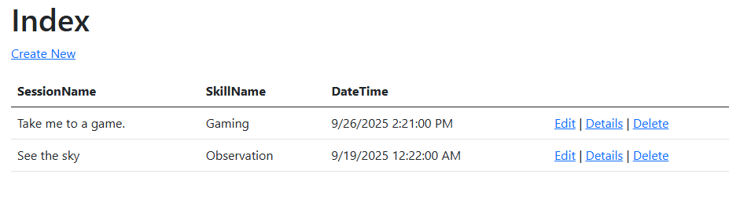
Reflection

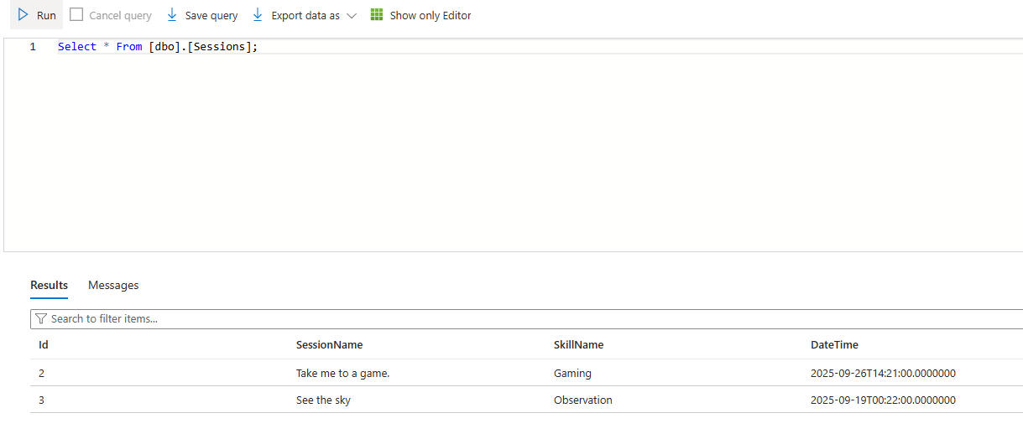
Edit

Intial



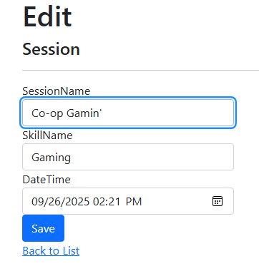
Reflection

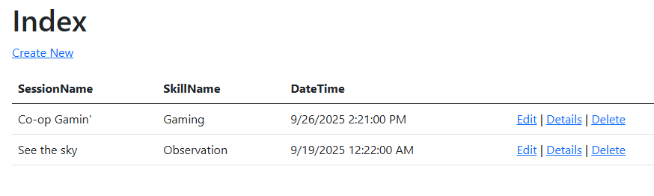

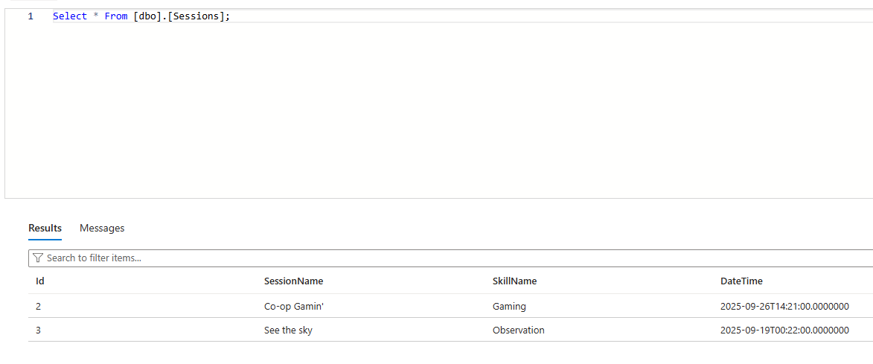
Delete

Initial



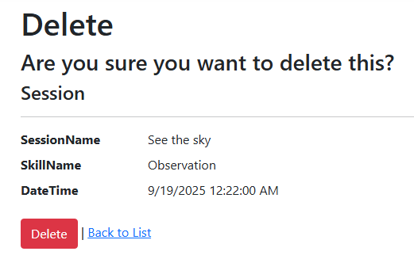
Reflection

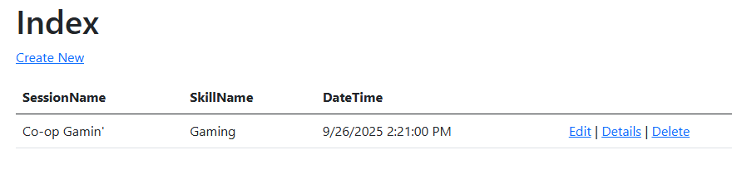

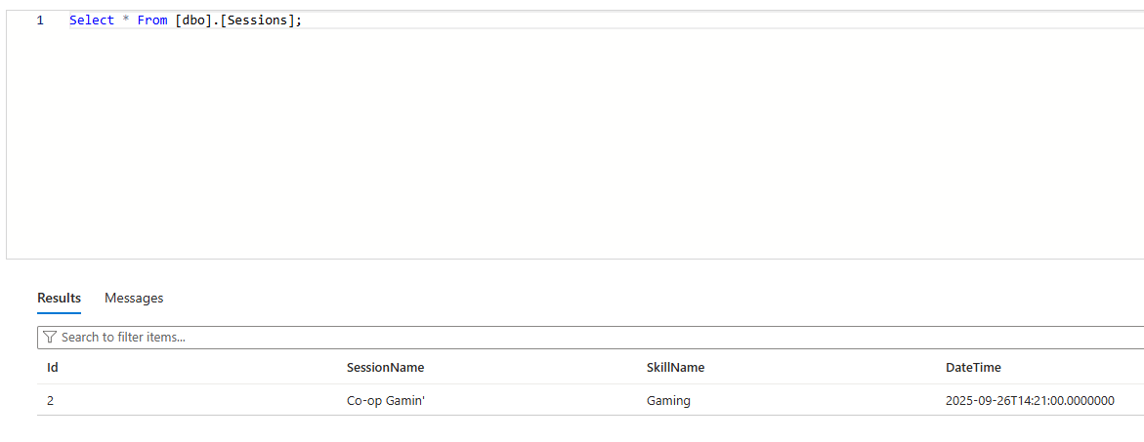
Code Base

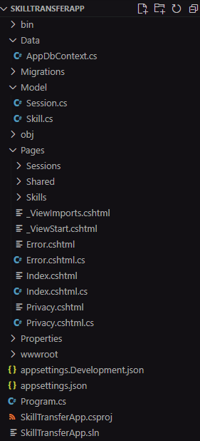

Models

Session

using System.ComponentModel.DataAnnotations;

namespace SkillTransferApp.Models
{
public class Session
{
[Key]
public int Id { get; set; }

public string? SessionName { get; set; }

public string? SkillName { get; set; }

public ICollection<Skill>? Skills { get; set; }

public DateTime DateTime { get; set; }
}
}

Skill

using System.ComponentModel.DataAnnotations;

namespace SkillTransferApp.Models
{
public class Skill
{
[Key]
public int Id { get; set; }

public string? StringName { get; set; }

public int Proficiency { get; set; }

public ICollection<Session>? Sessions { get; set; }
}
}

AppDbContext.cs

using Microsoft.EntityFrameworkCore;
using SkillTransferApp.Models;

public class AppDbContext : DbContext
{
public AppDbContext(DbContextOptions<AppDbContext> options) : base(options) { }

public DbSet<Session> Sessions { get; set; }
public DbSet<Skill> Skills { get; set; }
}

Appsettings.json

{
"Logging": {
"LogLevel": {
"Default": "Information",
"Microsoft.AspNetCore": "Warning"
}
},
"ConnectionStrings": {
"DefaultConnection": "Server=tcp:rixassessmentserver.database.windows.net,1433;Initial Catalog=rixassessmentdb;Persist Security Info=False;User ID=nisanthrz;Password=Password@12345;MultipleActiveResultSets=False;Encrypt=True;TrustServerCertificate=False;Connection Timeout=30;"
},
"AllowedHosts": "*"
}

Program.cs

using Microsoft.EntityFrameworkCore;

var builder = WebApplication.CreateBuilder(args);

// Add services to the container.
builder.Services.AddRazorPages();

// Use SQL Server instead of MySQL
builder.Services.AddDbContext<AppDbContext>(options =>
options.UseSqlServer(builder.Configuration.GetConnectionString("DefaultConnection")));

var app = builder.Build();

// Configure the HTTP request pipeline.
if (!app.Environment.IsDevelopment())
{
app.UseExceptionHandler("/Error");
// The default HSTS value is 30 days. You may want to change this for production scenarios, see https://aka.ms/aspnetcore-hsts.
app.UseHsts();
}

app.UseHttpsRedirection();
app.UseStaticFiles();

app.UseRouting();

app.UseAuthorization();

app.MapRazorPages();

app.Run();

